# xRecording A Session

1. At start of recording, make note of high-impedance in any of the channels.
2. Start recording. Give appropriate name to recording file (**EnrollmentID#**).file extension.
3. Begin **baseline, eyes-closed** recording session (**2-minute eyes-closed period**). Use **Mark 1\*** in the **Markers** tab of the software program. (1) Make sure the curtain is closed, (2) make sure no one is speaking in the preop bay at the time, and (3) keep lights on – this will probably be easier and more realistic in terms of experimental consistency (plus, lights will also be on in the OR and PACU). As much as possible, ensure that no one else is in the pre-op bay speaking with the patient. If this period is interrupted (i.e., surgeon coming in to chat with patient), that’s okay. Participant can stop and engage in conversation. Re-attempt to start 2-minute eyes-closed session afterwards, and just keep a log (paper and/or on the computer) of the timing of these sessions. Ultimately, **make sure you have logged the correct (based on the *computer clock*) time of the full, eyes-closed 2-minute baseline period.**

**\****Note: for each event recorded during the entire experimental procedure, use “Mark 1” – this will help with experimental consistency, and we can always make a note of what that “Mark 1” entailed at the time (e.g., 2-minute baseline recording begin/end, loss of consciousness, return of consciousness)*

1. It’s recommended to stay at some distance (~2 to 3 feet) from the participant and to minimize crowding and electronics around the participant.
2. Follow patient into the operating room. Ensure that you have a mask and scrub cap on for appropriate OR attire.
3. Once settled in the OR, try to stay at least 2-3 feed away from participant, sitting in a stool (if you can find one) so that you’re not in the way of the anesthesia team.
4. Shortly after the anesthesia team begins giving anesthetic medications, mark **loss of consciousness** (again **Mark 1**) after this patient stops responding to commands. This will entail the anesthetist asking questions like, “are you warm enough? How are you doing?” and not hearing a response. Then, the anesthetist will reach for a green bag to start breathing for the patient. When you see this sequence of events, hit **Mark 1 (**and record **loss of consciousness**).
5. Continue recording via the cognionics computer interface, checking impedances, issues, etc. If at any point you need to adjust electrodes, just check with the anesthesia team first to make sure it is safe to approach the patient to do so.
6. Routinely double-check that the USB stick with the green light is firmly in (I recommend putting some tape on it to make sure it’s not knocked out), battery life is okay, etc. If battery life is running low, **text/page a teammate for a new battery**. There should be plenty of electrical outlets as well in the OR for the laptop computer.
7. At the conclusion of surgery/anesthesia, the anesthesia team will discontinue all anesthetic medication. Our practice here is to ask patients to “squeeze our hand” when they have once again become conscious. When this happens, and they are squeezing the anesthetist’s hand and/or following commands, **mark return of consciousness (Mark 1).**
8. Accompany patients to the recovery unit. Once the “dust settles” and the patient is stable (check with the nurse) perform our **post-surgery, eyes-closed 2-minute recording**. This is done *just* like the baseline, 2-minute eyes closed period above. Make sure times are recording accurately. You’ll likely have to wait at least 15-20 minutes to do this test, as the nursing staff usually needs 15-20 minutes to get the patient stable, settled, etc.

# xUsing the PC and Software

Password: excelsior or Excelsior

When recording, have no other programs running

When recording, also have the Wi-Fi turned off. Network settings are available in the lower right toolbar

The extra drive has 1 TB data storage, so the computer should serve as Repository #1 of appropriately named data recordings, which should also be copied elsewhere after each run (i.e., to the shared online folder via USB stick from the PC to a networked computer).

There is Google Chrome on the PC in case web access is needed.

MATLAB, EEGLAB, and CARTOOL have been loaded for reviewing the data as necessary

All “necessary” programs are in the lower toolbar.

IT IS NOT RECOMMENDED that any Microsoft or other products be installed. **The PC should be only for recording, temporary data storage, and data review**.

Click the Cognionics icon on the toolbar at the bottom of the desktop.

This will open the Cognionics Data Acquisition Window at the **DEVICE TAB**. If the USB is plugged in and the amp is powered on, the Cognionics Wireless EEG D21130 Device should be detected, the gel wireless electrode set.

Leave the accelerometer checked On. Click Connect. It should ask whether to Auto-configure, click Yes.

You are now in the Cognionics Device Configuration window. You should see 16 channels ordered as expected in a list and a spatial map. Samples should remain at 500. Amplifier gain can stay at 3. Input is Normal. Click Write to Device and Start. You should see evidence of signal in the Raw EEG display tab. It will look crazy if impedances are not done or values are being shown at an innacurate scale.

When you want to start to record, click RECORD. Select a filename, location, and filetype. Use EDF files for the time being. Click STOP RECORDING to end the recording for that data file.

Click the DISPLAY tab in order to modify time scaling to 10, and scale the EEG as necessary. You may also show yourself some or all channels, or have two pages each with a subset of the channels. FILTERING is recommended for viewing the signal at 1-40 hz. One should toggle between 1-40 hz and 1-100 hz just to see what things look like after one has done impedances and is ready to record. Looking at the signal without the 100 hz lowpass filter can help you detect degree of noise in the signal.

Get familiar with all buttons and tabs in the software, so there is no learning curves or mistakes once recording starts.

During pre-testing/piloting one should play around with some settings to see what they do, as they may come in useful during recording (for example you may have an extrme channel that you want to mask out with mask Hi-Z channels.

The CHANNELS tab is where to go see the channel list, see current impedances and voltages. Click on the little area in the lower right of the Channel Impedance display to be able to maximize it, so as to read values easily during prepping, and as necessary during recording. Full screen impedances while doing impedances is storngly recommended.

Markers allows one to click one of 8 markers that will “show up” in the recorded eeg.

The accelerometer recording will be useful to track movement.

The ASR TAB is used if one wants to record a baseline period that is used to “clean” up subsequent data that is recorded during the session. One can save a new ASRed file, and one can view the ASR cleaned signal. Please consult with Tarik or Brain Vision for more info on this method. One can try it with no effect on the raw data that is being recorded.

# Starting a Recording (EEG, EMG, ECG)

**Step 1:** **Set up**

* **EEG**

1. Connect all the electrodes (except reference and ground electrodes) to the mainboard’s (Cyton + Daisy) 16 channels. For both Cyton and Daisy, connect only bottom pins of 1p-8p to electrodes.
2. Use a Y-splitter to connect both SRB bottom pins to reference electrode.
3. Connect the bottom pin of BIAS (either Cyton or Daisy) to ground electrode.

4. Plug the Cyton to battery.

* **ECG**

1. Connect the ECG (pulse sensor) to the mainboard. Black wire to GND, red wire to VDD, and purple wire to D11.

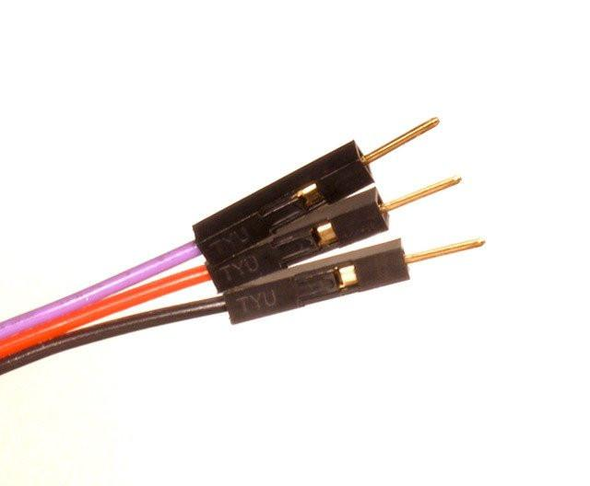

**To black**

**To purple**

**To red**

* **EMG**

1. Clip the pre-gelled electrodes onto EMG.
2. Connect the EMG to the mainboard. “+” to VDD, “-”to GND, “SIG” to D12.

Note: (i) For simultaneously working of EMG and ECG, GND and VDD can be shared by using Y-splitters. (ii) EMG signals can also be obtained by connecting one of the 16 high resolution channels. Connect R to BIAS(top pin), E to any top pin from 1p-8p, and M to corresponding bottom pin.

1. Place EMG along the longitudinal midline of the desired muscle with the arrow parallel to the muscle fibers. DO NOT place the sensor at the outside edges of the muscle. DO NOT place the sensor on or near the motor point. DO NOT place the sensor on or near the tendon of the muscle.

**Step 2:** **Data recording**

1. Turn the switch of mainboard (Cyton) to PC. Turn on the switch of EMG. Plug the USB Bluetooth dongle into computer. If using the WIFI shield, insert the WIFI shield between Cyton and Daisy, connect another set of battery, and turn on the switch of WIFI shield. (Setting up of WIFI shield refers to OPENBCI online tutorial : <https://docs.openbci.com/docs/01GettingStarted/01-Boards/WiFiGS> )

1. Launch OpenBCI_GUI.exe

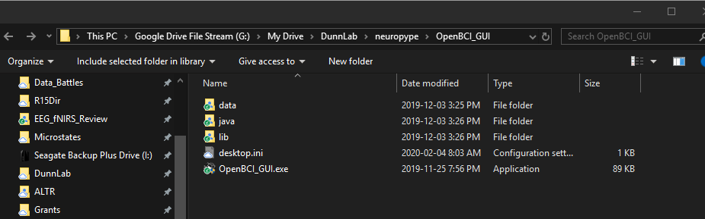

1. Open the software of OPENBCI.
2. 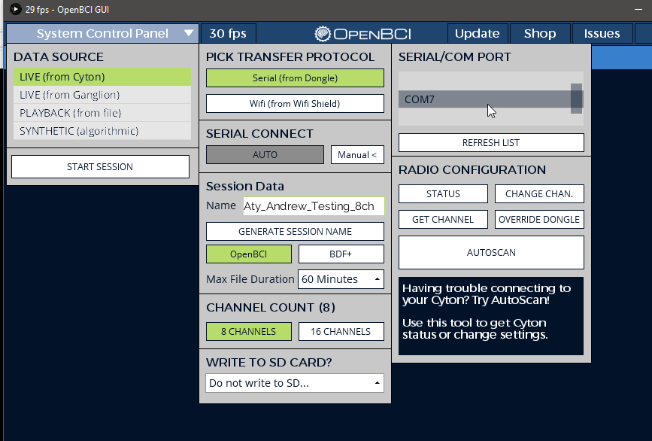A screenshot of a cell phone

   Description automatically generated

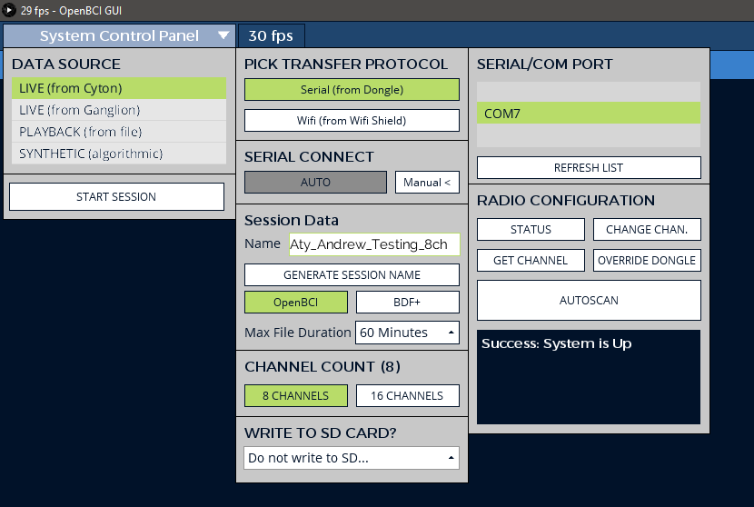

Choose LIVE (from Cyton) — Serial (from Dongle) (choose WIFI if using WIFI shield) – Corresponding Serial # -- OpenBCI – 16 CHANNELS, and then click “START SYSTEM”.

In Time Series plots, Channel 1-16 indicates EEG (Channel 1-8 correspond to Cyton 1p-8p, Channel 9-16 correspond to Daisy 1p-8p). In Analog Read, A5(D11) indicates ECG, A6(D12) indicates EMG.

1. To start recording, click “Start Data Stream”. In Analog Read, click “Turn Analog Read On” to virtualize EMG and ECG signals.

Note: If Analog Read is not open on the interface or not turned on, EMG and ECG signals will not be recorded.

1. To live stream data, open Networking, choose “LSL” in Protocol. Turn the desired stream on, and click “Start”.

